NAMA : YOGAS EKA PUTRA

KELAS : CS-40-01

TUGAS PENDAHULUAN MODUL 9

#include<stdio.h>

//cara1

typedef struct{

char* name;

int price;

int cooldown;

int mana_required;

}Item;

//cara2

struct Hero{

int strength;

int agility;

int intellegence;

Item slot1,slot2,slot3;

};

void make_hero(struct Hero *X, int str, int agi, int itg){

//assign nilai atribut ke hero

X->strength = str;

X->agility = agi;

X->intellegence = itg;

}

void hero_type(struct Hero X){

//cetak tipe hero (strength/agility/intellegence), attribute dengan nilai tertinggi merupakan tipe hero tersebut.

//misalkan Pudge(25,14,14), maka tipenya Strength

printf("HERO BER-TYPE = ");

if((X.strength > X.agility) && (X.strength > X.intellegence)){

printf("STRENGHT");

} else if ((X.agility > X.intellegence) && ( X.agility > X.strength)){

printf("AGILITY");

} else {

printf("INTELLEGENCE");

}

}

void hero_info(struct Hero X){

//cetak atribut, tipe, dan item pada hero

printf("strenght = %d \n",X.strength);

printf("agility = %d \n",X.agility);

printf("intellegence = %d \n",X.intellegence);

hero_type(X); printf("\n");

printf("ITEM HERO = %s | %s | %s \n",X.slot1.name ,X.slot2.name ,X.slot3.name);

printf("COOLDOWN ITEM = %d | %d | %d \n",X.slot1.cooldown ,X.slot2.cooldown ,X.slot3.cooldown);

printf("MANA HERO = %d | %d | %d \n",X.slot1.mana_required ,X.slot2.mana_required ,X.slot3.mana_required);

// printf("TOTAL HARGA ITEM = %d \n",X.slot1.price + X.slot2.price + X.slot3.price);

}

void item_init(Item *I,char* nam, int prc, int cld, int mnrq ){

//isi keterangan item seperti name, price, cooldown, dan mana_required

I->name = nam;

I->price = prc;

I->cooldown = cld;

I->mana_required = mnrq;

}

void buying_item(struct Hero *X, Item item1, Item item2, Item item3){

//pasangkan hero dengan item, assign item ke slot hero.

X->slot1 = item1;

X->slot2 = item2;

X->slot3 = item3;

}

struct Hero richest_hero(struct Hero X){

//BONUS

//tentukan hero dengan total harga item termahal

int sum0;

sum0 = X.slot1.price + X.slot2.price + X.slot3.price;

printf("TOTAL HARGA ITEM = %d \n", sum0);

}

int main(){

struct Hero

Skywrath_Mage,

Necrophos,

Viper,

Outworld_Devourer,

Pudge;

Item item[5];

item_init(&item[0],"Rod_of_Atos",3100,16,50);

item_init(&item[1],"Dagon",7200,15,180);

item_init(&item[2],"Divine_Rapier",6200,0,0);

item_init(&item[3],"Scythe_of_Vyse",5700,25,100);

item_init(&item[4],"Aghanim_Scepter",4200,0,0);

make_hero(&Skywrath_Mage,19,13,27);

make_hero(&Necrophos,16,15,22);

make_hero(&Viper,20,21,15);

make_hero(&Outworld_Devourer,19,24,26);

make_hero(&Pudge,25,14,14);

buying_item(&Skywrath_Mage,item[0],item[3],item[4]);

buying_item(&Necrophos,item[1],item[3],item[4]);

buying_item(&Viper,item[1],item[2],item[4]);

buying_item(&Outworld_Devourer,item[0],item[2],item[3]);

buying_item(&Pudge,item[4],item[3],item[1]);

printf("Skywrath Mage's Attribute:\n");

hero_info(Skywrath_Mage);

richest_hero(Skywrath_Mage);

printf("============================\n");

printf("Necrophos' Attribute:\n");

hero_info(Necrophos);

richest_hero(Necrophos);

printf("============================\n");

printf("Viper's Attribute:\n");

hero_info(Viper);

richest_hero(Viper);

printf("============================\n");

printf("Outworld_Devourer's Attribute:\n");

hero_info(Outworld_Devourer);

richest_hero(Outworld_Devourer);

printf("============================\n");

printf("Pudge's Attribute:\n");

hero_info(Pudge);

richest_hero(Pudge);

}

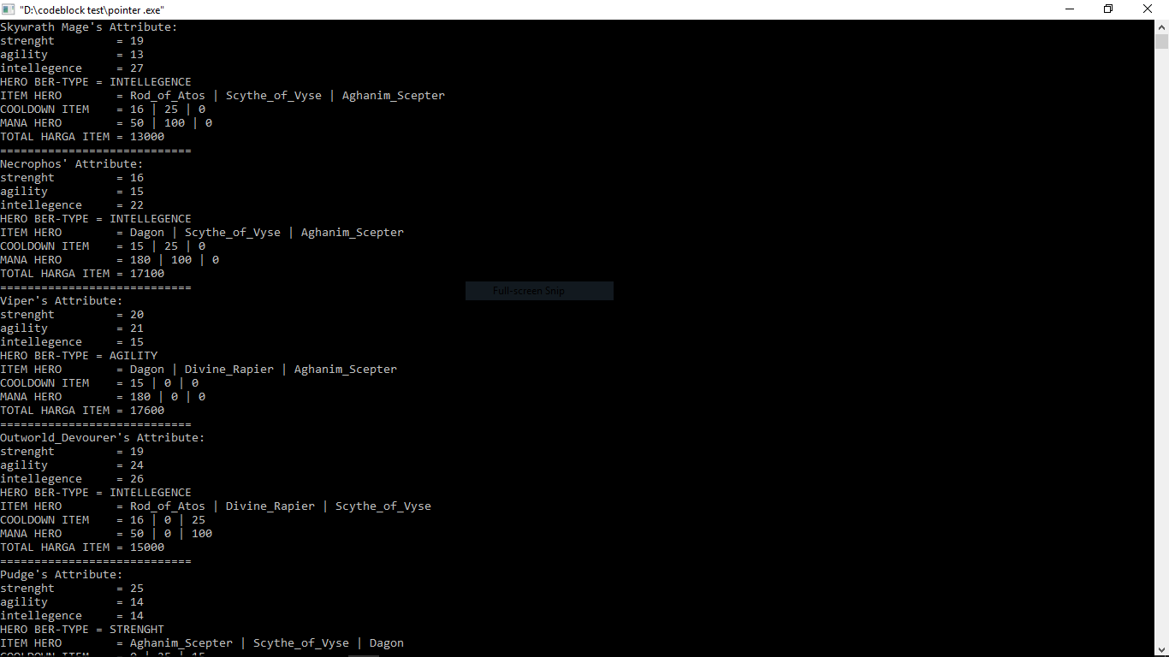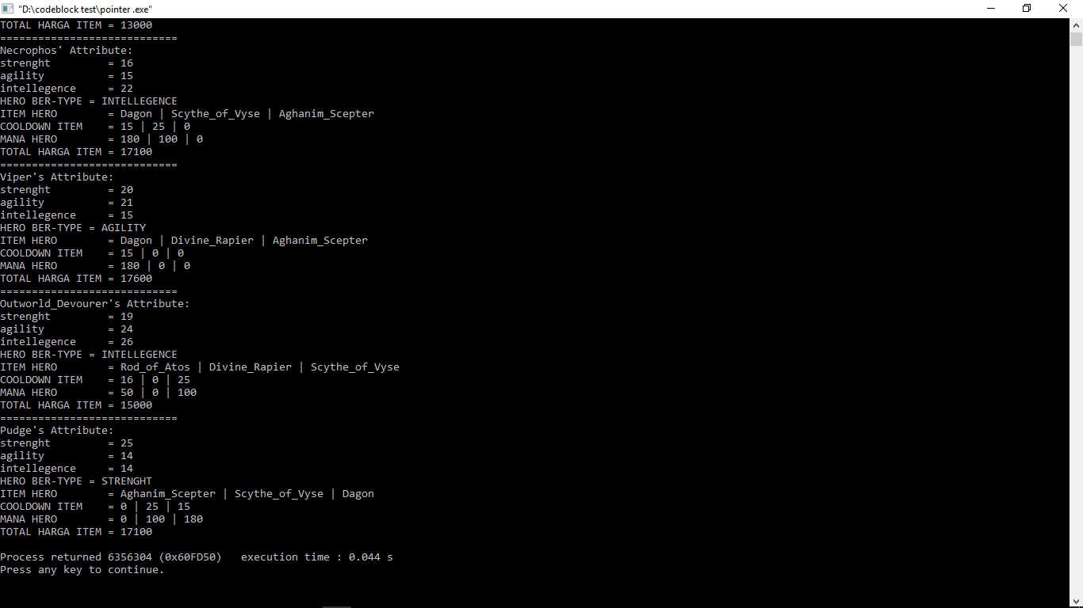

| "Saya mengerjakan tugas ini dengan jujur dan tidak melakukan pelanggaran aturan dari IFLAB. |

| Jika saya terbukti melanggar, maka saya bersedia menerima sanksi yang berlaku." |